**SR GLOBAL SCHOOL**

**PRE BOARD EXAM-II (2022-2023)**

**CLASS-XII**

**SUBJECT-PHYSICS (042)**

**Time: 3 Hrs. M:M: 70 Marks**

**GENERAL INSTRUCTIONS:**

* **There are 35 questions in all. All questions are compulsory**
* **This question paper has five sections: Section A, Section B, Section C, Section D and Section E. All the sections are compulsory.**
* **Section A contains eighteen MCQ of 1 mark each, Section B contains seven questions of two marks each, Section C contains five questions of three marks each, section D contains three long questions of five marks each and Section E contains two case study based questions of 4 marks each.**
* **There is no overall choice. However, an internal choice has been provided in section B, C, D and E. You have to attempt only one of the choices in such questions.**
* **Use of calculators is not allowed**

**SECTION-A (1 MARK EACH)**

**1.** The electric potential inside a conducting sphere _____________

1. is zero
2. increases from centre to the surface
3. decreases from centre to the surface
4. remains constant from centre to the surface

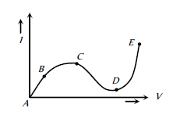**2.** From the graph between current I and voltage V shown below, identify the portion corresponding to negative resistance

a. AB b. BC c. CD d. DE

**3.** In the equation AB = C, A is the current density, C is the electric field, Then B is  
a. resistivity b. conductivity c. potential difference d. resistance

**4.** To minimise the power loss in the transmission cables connecting the power stations to homes and factories, the transmission cables carry current

a. at a very low voltage. b. at a very high voltage  
c. at 220 volt d. neither at a very high voltage nor at a very low voltage.

**5.** A proton (mass m and charge +e) and an α particle (mass 4m and charge +2e) are projected with the same kinetic energy at right angles to the uniform magnetic field. Which one of the following statements will be true

1. The α particle will be bent in a circular path with a small radius that for the proton
2. The radius of the path of the α particle will be greater than that of the proton
3. The α particle and the proton will be bent in a circular path with the same radius
4. The α particle and the proton will go through the field in a straight line

**6. In an inertial frame of reference, the magnetic force on a moving charged particle is F  Its value in another inertial frame of reference will be**  
 a. remained same  
 b. changed due to change in the amount of charge  
 c. changed due to change in velocity of charged particle  
 d. changed due to change in field direction

**7.** The nature of parallel and anti-parallel currents are-  
 a. parallel currents repel and anti parallel currents attract.

b. parallel currents attract and anti parallel cur-rents repel.  
c. both currents attract.   
d. both currents repel.

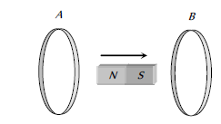**8.** In the diagram shown if a bar magnet is moved along the common axis of two single turn coils A and B in the direction of arrow

a. Current is induced only in A & not in B

b. Induced currents in A & B are in the same direction

c. Current is induced only in B and not in A

d. Induced currents in A & B are in opposite directions

**9. An AC voltage source of variable angular frequency ω and fixed amplitude V0 is connected in series with a capacitance C and an electric bulb of resistance R (inductance zero). When ω is increased then,**

a. The bulb glows dimmer  
b. The bulb glows brighter  
c. Total impedance of the circuit is unchanged  
d. Total impedance of the circuit increases

**10.** Normal light is due to:  
a. electric field oscillations.  
b. magnetic field oscillations.  
c. oscillations of electric and magnetic fields in mutually perpendicular directions.  
d. None.

**11.** Which of the following is used to investigate the structure of solids?

a. Gamma Rays b. Infrared Rays c. X-Rays d. Cosmic Rays

**12.** A beam of light consisting of red, green and blue colours is incident on a right angled prism. The refractive index of the material of the prism for the above red, green and blue wavelengths are 1.39, 1.44 and 1.47, respectively. The prism will :-

a. separate the red colour part from the green and bluecolours

b. separate the blue colour part from the red and green colours

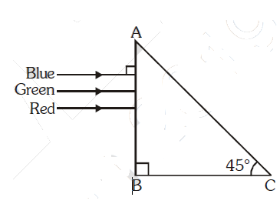c. separate all the three colours from one another

d. not separate the three colours at all

**13.** The earth takes 24 h to rotate once about its axis. How much time does the sun take to shift by 10 when viewed from the earth?

a. 14 second b. 14 minute c. 4 second d. 4minute

**14.** Shown in the figure here is a convergent lens placed inside a cell filled with a liquid. The lens has focal length + 20 cm when in air and its material has refractive index 1.50. If the liquid has refractive index 1.60, the focal length of the system is

a. + 80 cm b. – 80 cm c. – 24 cm d. –100 cm

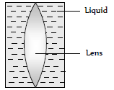

**OR**

A graph is plotted between angle of deviation δ and angle of incidence (i) for a prism. The nearly correct graph is

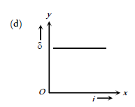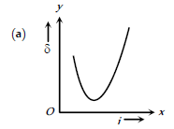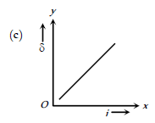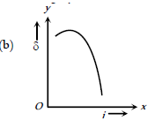

**15.** Huygen's conception of secondary waves

a. Allow us to find the focal length of a thick lens

b. Is a geometrical method to find a wavefront

c. Is used to determine the velocity of light

d. Is used to explain polarization

Two statements are given-one labelled

**Assertion (A)** and the other labelled

**Reason (R)** Select the correct answer to these questions from the codes (a), (b), (c) and (d) as given below.

a. Both A and R are true and R is the correct explanation of A.

b. Both A and R are true and R is not the correct explanation of A.

c. A is true but R is false

d. A is false and R is also false

**16. Assertion (A):** In reverse biased, no current flow through the junction.

**Reason (R) :** The dominant mechanism for motion of charge carriers in forward and reverse biased silicon p-n junction are drift in both forward and reverse bias.

**17. Assertion (A):** Interference obeys the law of conservation of energy.

**Reason (R):** The energy is redistributed in case of interference.

**18. Assertion (A):** In photoelectric effect, on increasing the intensity of light, both the number of electrons

emitted and kinetic energy of each of them get increased but photoelectric current remains unchanged.

**Reason (R):** The photoelectric current depends only on wavelength of light.

**SECTION-B (2 MARKS EACH)**

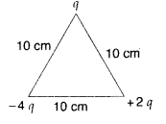**19.** Calculate the work done to dissociate the system of three charges placed on the vertices of a triangle as shown. If q = 2microcoulomb

**20.** Derive ohms law in vector form

**21.** A capacitor (C) and resistor (R) are connected in series with an ac source of voltage of frequency 50 Hz. The potential difference across C and R are respectively 120 V, 90 V, and the current in the circuit is 3 A. Calculate the impedance of the circuit

**22.** How does a charge q oscillating at certain frequency produce electromagnetic waves? Sketch a schematic diagram depicting electric and magnetic fields for an electromagnetic wave propagating along the Z-direction.

**23.** Write three basic properties of photons which are used to obtain Einstein’s photoelectric equation. Use this equation to draw a plot of maximum kinetic energy of the electrons emitted versus the frequency of incident radiation

**24.** **Draw the circuit diagram showing how a p-n junction diode is  
(i)forward biased (ii)reverse biased.  
How is the width of depletion layer affected in the two cases**

**25. A p-n junction How are these characteristics made use of in rectification?**

**SECTION-C (3 MARKS EACH)**

**26.** Define the term conductivity of a metallic wire. Write its SI unit.Using the Concept of free electrons in a conductor, derive the expression for the conductivity of a wire in terms of number density and relaxation time. Hence obtain the relation between current density and the applied electric field E.

**OR**

A steady current flows in a metallic conductor of non- uniform cross-section. Which of these quantities Is constant along the conductor: current, current density, electric field, drift speed?

Deduce the relation between current I flowing through a conductor and drift velocity of the

elections.

**27.** With the help of a neat and labelled diagram, explain the principle of a moving coil galvanometer.

(i) What is the function of uniform radial field and how is it produced?

(ii) Define current sensitivity of a galvanometer. How is current sensitivity increased?

**28.** Light of wavelength 2000 Å falls on a metal surfaceof work function 4.2 eV.

(a)What is the kinetic energy (in eV) of the fastest eiectrons emitted from the surface?

(b) What will be the change in the energy of the emitted electrons if the intensity of light with same wavelength is doubled?

(c)If the same light falls on another surface of work function 6.5 eV, what will be the energy of

Emitted electrons?

**29.** The following table gives the values of work functions for a few sensitive metals.

|  |  |  |
| --- | --- | --- |
| S. No. | Metal | Work function(eV) |
| 1. | Na | 2.01 |
|  |  |  |
| 2. | K | 3.79 |
| 3. | Mo | 4.17 |

If each of these metals is exposed to radiations of wave length 330 nm, which of these will not exit photoelectrons and why?

**30.** Distinguish between conductors, insulators and semiconductors on the basis of energy band diagrams.

**SECTION-D (5MARKS EACH)**

**31.** (i) The electric field components in Fig are Ex = αx 1/2 , Ey = Ez = 0, in which α = 1600 N/C m1/2. Calculate

(a) the flux through the cube, and

(b) the charge within the cube. Assume that a = 0.2 m.

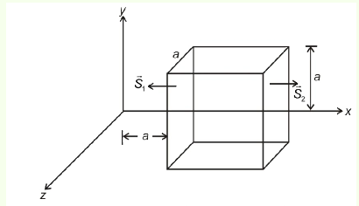

(ii) derive an expression for electric field intensity due to a long straight thin uniformly charged wire .

**OR**

**(a) A charge of 8 mC is located at the origin. Calculate the work done in taking a small charge of https://cdn1.coolgyan.org/statics/12/physics/impq/2_5/image069.png from a point P (0, 0, 3 cm) to a point Q (0, 4 cm, 0), via a point R (0, 6 cm, 9 cm).**

**(b)** **A 4μf capacitor is charged by a 400 V supply. It is then disconnected from the supply, and is connected to another uncharged 2μf capacitor. How much electrostatic energy of the first capacitor is lost in the form of heat and electromagnetic radiation?**

**32.** (a) a  light bulb is rated 100 W for 220 V ac supply of 50 Hz. Calculate  
(i) the resistance of the bulb;  
(ii) the rms current through the bulb.

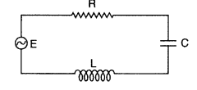(b) The figure shows a series LCR circuit connected to a variable frequency 200 V source with L = 50 mH, C = 80 µF and R = 40 Ω.

Determine  
(i) the source frequency which derives the circuit in resonance;

(ii) draw the phasor diagram of LCR circuit and also find expression for impedence and admittance how you can resolove paradox in LCR circuit

**OR**

1. 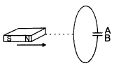Predict the polarity of the plate A of the capacitor, when a magnet is moved towards it, as shown in the figure
2. Define self-inductance of a coil. Show that magnetic energy required to build up the current I in a coil of self inductance L is given by
3. Write the loss in transformer .

**33.** (i) A small bulb is placed at the bottom of a tank containing water to a depth of 80cm. What is the area of the surface of water through which light from the bulb can emerge out? Refractive index of water is 1.33. (Consider the bulb to be a point source.)

(ii) Find the position of final image from 'O' for the Arrangement shown

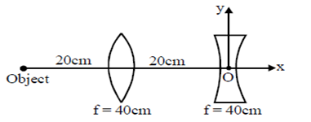

(iii) Derive lens maker formula

**OR**

(i) Draw a ray diagram to show the formation of the real image of a point object due to a convex spherical refracting surface, when a ray of light is travelling from a rarer medium of refractive index n1 to a denser medium of refractive index n2. Hence derive the relation between object distance, image distance and radius of curvature of the spherical surface.

(ii) Define wavefront. Use Huygens’ principle to verify the laws of refraction.

**SECTION-E (4 MARKS EACH)**

**CASE STUDY-I**

A compound microscope is an optical instrument used for observing highly magnified images of tiny objects. Magnifying power of a compound microscope is defined as the ratio of the angle subtended at the eye by the final image to the angle subtended at the eye by the object, when both the final image and the objects are situated at the least distance of distinct vision from the eye. It can be given that: m=me x mo, where me is the magnification produced by the eye lens and mo is the magnification produced by the objective lens.

Consider a compound microscope that consists of an objective lens of focal length 2.0 cm and an eyepiece of focal length 6.25 cm separated by a distance of 15 cm.

1. The object distance for eye-piece, so that final image is formed at the least distance of distinct vision, will be
2. The intermediate image formed by the objective of a compound microscope is
3. Magnification of a compound microscope is 30. Focal length of eyepiece is 5 cm and the image is formed at a distance of distinct visionof 25 cm. The magnification of the objective lens is
4. For a compound microscope, the focal lengths of object lens and eyelens are fo and fe respectively, then magnification will be done by microscope when

**OR**

If the focal length of objective and eye lens are 1.2 cm and 3 cm respectively and the object is put 1.25 cm away from the objective lens and the final image is formed at infinity. The magnifying power of the microscope is

**CASE STUDY-2**

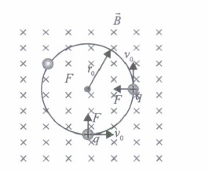the magnetic force is perpendicular to the velocity of the particle. So no work is done and no change in the magnitude of the velocity is produced (though the direction of momentum may be changed). [Notice that this is unlike the force due to an electric field, qE, which can have a component parallel (or anti parallel) to motion and thus can transfer energy in addition to momentum.] We shall consider motion of a charged particle in a uniform magnetic field. First consider the case of v perpendicular to B. The perpendicular force, q (**v × B)**, acts as a centripetal force and produces a circular motion perpendicular to the magnetic field. The particle will describe a circle if v and B are perpendicular to each other

(i) The radius of curvature of the path of the charged particle in a uniform magnetic field is directly proportional to

(ii) An electron is travelling horizontally towards east. A magnetic field in vertically downward direction exerts a force on the electron along

(iii) A proton enters a magnetic field of flux density 1.5 weber / m2 with a velocity of 2× 107 m/sec at an angle of 300 with the field. The force on the proton will be

**OR**

Why kinetic energy is not change when charge particle enter perpendicular to field

(iv) A charged particle of mass m and charge q describes circular motion of radius r in a uniform magnetic field of strength B. prove that The frequency of revolution is independent of velocity